

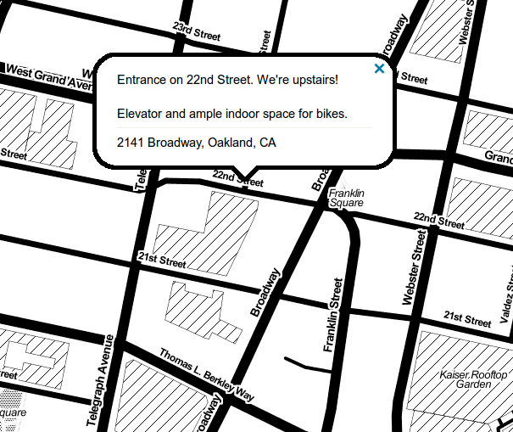

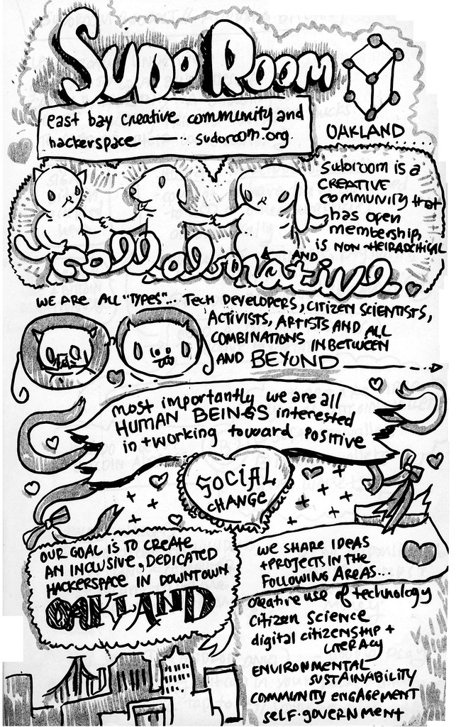
Values
sudo room is an open, collaborative community of creators and practitioners working toward positive social change. sudo room values:
- Open, public discourses over closed, proprietary processes.
- Access and transparency over exclusivity.
- Solving real problems over hypotheticals, while respecting visions of the future.
- Community and collaboration over isolation and competition.
- Human judgment over automation and efficiency.
- Do-ocracy over bureaucracy.
- Safe space over ideology.

Safe Space Policy
While Sudo Room strives to be radically inclusive, we are also committed to creating a safe space:

"A place where anyone can relax and be fully self-expressed, without fear of being made to feel uncomfortable, unwelcome, or unsafe on account of biological sex, race/ethnicity, sexual orientation, gender identity or expression, cultural background, age, or physical or mental ability; a place where the rules guard each person's self-respect and dignity and strongly encourage everyone to respect others."
— Advocates for Youth via Wikipedia

Get in touch!
- Come to a weekly meeting, Wednesdays starting at 7pm.
- Call the sudo room phone: 510.858.7145
- Join a mailing list: http://lists.sudoroom.org
- Chat with folks online: https://sudoroom.org/chat
- Come to an upcoming event: https://sudoroom.org/calendar

Become a member!
Member dues are sliding scale. Lockers available for $30/month.
Visit https://sudoroom.org/membership to learn more!
Projects:
- Sudo Mesh is creating a free wireless network for the East Bay, made of point-to-point connections between routers mounted on homes: https://sudomesh.org
- Oakland Wiki is a free website about Oakland that anyone can edit, with over 4700 entries on Oakland neighborhoods, historic places, local events & more: https://oaklandwiki.org
- We are powered by Sudo Mate – a delicious caffeinated yerba mate soda. It's open source! and often available for donation in our fridge: https://sudoroom.org/wiki/Sudomate
- The Sudouino is an Arduino-derived microcontroller clone kit designed with the hardware hacker in mind: https://sudoroom.org/wiki/Sudouino
- The Desktop Biolab is a microbiology laboratory kit for hacking on biology at home: https://omgbio.com

Meetups and Events:
- Today We Learned: Experiments in co-learning – share what you're working on & learn together! Saturdays from 2-5pm http://pad.riseup.net/p/twl
- Cryptoparty! Workshops on securing your laptop and phone every Third Sunday from 2-5pm. User & Developer tracks. Newbies welcome!
- The Timelist Group hosts monthly training and discussion about ending violence in the community, substance abuse and mass incarceration.
- Leather & Craft Workshop every First and Third Monday from 7-10:30pm
- Morning Math Jam – all levels welcome! Improve focus and intuition around problem-solving using math, every Tuesday and Thursday morning from 9-11:30am.
- East Bay Javascript Meetup every Thursday starting at 7pm: http://www.meetup.com/EBJavaScript
- Art Murmur Afterhours – come by Sudo Room after Oakland's monthly First Friday Art Murmur for music, tours and hacking!

